**Project 4: File System Manager**  
James Miller  
Grand Canyon University  
CST 315: Operating Systems  
Dr. Citro  
April 16, 2023

**GitHub Link**

<https://github.com/jammil002/Project1--Unix-Command-Line>

**Explanation of Design**

The File System Manager is designed to handle file and directory operations within the Turtle Shell, providing a convenient way for users to interact with the file system. It added support for common tasks such as creating, renaming, deleting, and modifying files and directories, while also offering additional features to enhance the overall user experience.

**Concept and Analysis**

The concept of the File System Manager is to provide an abstraction layer between the shell and the underlying file system, making it easier for users to perform file and directory operations without having to worry about the specific implementation details. In order do this I had to understand the essential functionalities that should be offered by the File System Manager and understanding how they can be integrated with the existing Turtle Shell program.

**Implementation**

The implementation of the File System Manager can be broken down into a few key components:

1. Abstraction Layer: The File System Manager should provide a consistent interface for interacting with the file system, abstracting away the underlying implementation details. This can involve creating classes or functions that represent common file system operations, such as creating, renaming, and deleting files or directories.
2. Integration with Turtle Shell: The File System Manager should be integrated with the existing Turtle Shell program, allowing users to access file system operations through shell commands. This can involve modifying the input parsing and command execution components of the Turtle Shell to recognize and execute file system-related commands.
3. Error Handling: The File System Manager should handle errors and exceptions that may occur during file system operations. This can involve checking for invalid input, catching exceptions thrown by the operating system, and providing helpful error messages or suggestions to the user.

**Testing and Validation** 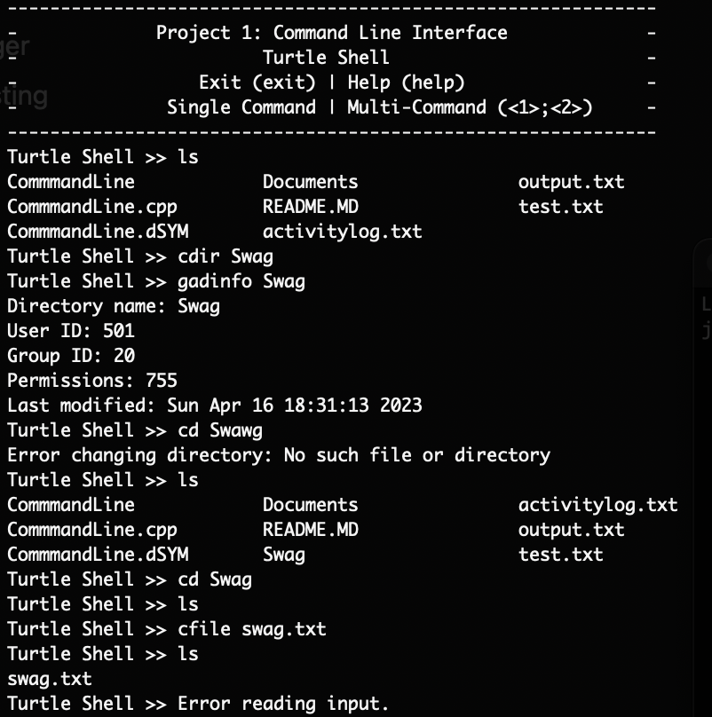

**References**